

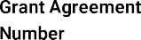
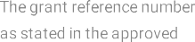
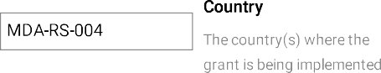

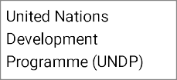






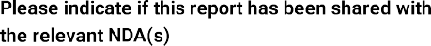



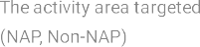
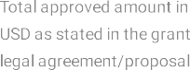
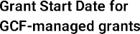
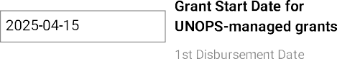
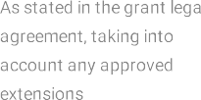

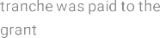

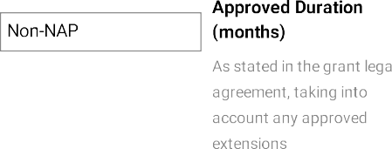

The reporting period (15 April–31 December 2025) covered the official start-up and initial implementation phase of the project “Capacity building for climate action in the Republic of Moldova”. The overall objective of the project is to strengthen institutional, technical, and coordination capacities in the Republic of Moldova to effectively plan, implement, and finance climate action in line with the country’s Nationally Determined Contribution, national climate strategies, and European Union integration commitments.

During the reporting period, the project made progress toward its objective by establishing the enabling conditions for coordinated climate action. The Inception Workshop played a central role in confirming national priorities, identifying sector-specific needs, and initiating dialogue on policy development and climate investment planning across water, energy, forestry, health, transport, and agriculture sectors.

Institutional groundwork was laid to strengthen climate governance through support to the National Designated Authority and the National Climate Change Commission framework, while analytical and preparatory work was initiated to inform future policy updates and project pipeline development. Although most technical outputs are scheduled for later implementation phases, progress achieved during this initial period is consistent with the approved logframe and reflects an appropriate focus on start-up, coordination, and stakeholder engagement.

A major milestone of the reporting year was the organization of the Inception Workshop on 31 October 2025, which formally launched the project and convened representatives of central public authorities, development partners, academia, civil society, and the private sector. The workshop confirmed strong national ownership of the project objectives and validated their relevance in the context of Moldova’s enhanced NDC 3.0, the Climate Action Law (2024), and the country’s EU accession commitments. In parallel, consultations with the National Designated Authority and key stakeholders informed the strategic sequencing of activities across policy, investment pipeline, and knowledge management components.

In the area of climate finance pipeline development, the NDA recommended that support under the project be oriented toward the development of concept notes not only for the Green Climate Fund, but also for other international climate finance institutions. The NDA further advised that project activities be reviewed to allow flexibility, including potential reallocation of resources toward feasibility and preparatory studies where this would better support the development of bankable investment proposals. This guidance has been taken into account in planning activities for subsequent implementation phases.

Key progress achieved during the reporting period included: (i) initiation of institutional arrangements for project governance and coordination; (ii) identification and validation of sectoral priorities for mitigation and adaptation in support of NDC implementation; (iii) clarification of National Designated Authority (NDA) needs related to climate governance, monitoring, reporting, and access to international climate finance; and (iv) preparatory actions for modernizing the national Climate Change Information and Knowledge Management Portal (CCIKMP) as a transparency and knowledge-sharing instrument.

Implementation during this initial phase was shaped by the project’s effective start date in April 2025 and the need to align activities with parallel national and EU-supported processes. Adaptive management approaches were applied to ensure complementarity with ongoing initiatives and to sequence activities in a manner consistent with GCF Readiness guidance.
In the next reporting period, the project will transition from start-up and consultation to accelerated delivery of substantive outputs. Priorities for 2026 include: (i) operationalization and regular functioning of the National Climate Change Commission and its Secretariat; (ii) development and strengthening of policy instruments and action plans supporting NDC 3.0 implementation and EU climate acquis alignment; (iii) enhanced institutional and technical capacity for development of bankable climate investment concept notes and project proposals; and (iv) modernization and active use of the Climate Change Information and Knowledge Management Portal to support evidence-based decision-making and stakeholder engagement.
Overall, progress during the reporting year aligns with GCF Readiness objectives and provides a solid foundation for scaled-up implementation in subsequent years.
15/04/2025
31/12/2025

Highlight the type of challenge. Choose as many as you need
Political
Procurement
Legal
Sanctions
Other (e.g. covid19, cyber security)
Compliance
Environmental and social safeguards
Gender
Indigenous peoples
Financial
Prohibited practices
Ethics and conflict of interest
AML/CFT
Fiduciary standards
SEAH
Whistle blowers
No challenges encountered

Challenges and lessons learned (please link the description to one of the challenge types, above)

Challenges
Implementation during the reporting period faced several challenges typical of an initial start-up phase. The effective project start in October 2025 reduced the available implementation window for the year, requiring careful sequencing of activities and prioritization of foundational actions. In addition, Parliamentary elections held in the Republic of Moldova in September 2025 resulted in the formation of a new Government, which required the postponement of the Inception Workshop to ensure that newly appointed decision-makers and institutional leaders could be effectively engaged. While this approach strengthened national ownership and relevance of project discussions, it led to a short delay in the initiation of some activities.
In parallel, the project operates in a dynamic policy environment, with several climate-related strategies and analytical processes supported by the European Union and bilateral partners (NDC Partnership for example) progressing simultaneously. This created risks of overlap and timing misalignment, particularly for policy-oriented deliverables dependent on external processes.
Additional challenges related to the need for extensive inter-institutional coordination across sectors, as climate action responsibilities are distributed among multiple line ministries and agencies. Ensuring common understanding of roles, expectations, and timelines required sustained consultation and contributed to longer preparation periods for certain activities.

Lessons Learned
Key lessons from the reporting period highlight the importance of early and continuous stakeholder engagement, as demonstrated by the Inception Workshop, which proved critical for validating priorities, identifying risks, and building ownership across institutions. The experience also confirmed the value of adaptive management under GCF Readiness support, allowing activities to be refined and sequenced to maintain complementarity with parallel initiatives while safeguarding relevance to national priorities.
The initial phase further underscored the need to invest early in coordination mechanisms and knowledge-sharing tools, as these enable more efficient implementation of technical and policy activities in later stages. These lessons will inform implementation planning and risk management in the subsequent reporting period.














During the reporting period (15 April–31 December 2025), progress under Objective 1 focused on establishing the institutional and coordination foundations required for effective climate governance in the Republic of Moldova. Given that the project entered its operational phase only in mid-April 2025, and was only able to hold its inception workshop in October 2025, the emphasis was placed on enabling actions, stakeholder engagement, and institutional setup rather than the delivery of fully operational coordination mechanisms.
A key achievement during the period was the consolidation of national ownership and strategic direction for climate governance through the Inception Workshop and related consultations. These processes confirmed the central role of the National Climate Change Commission (NCCC) as the country’s high-level coordination body for climate policy and NDC 3.0 implementation, and highlighted the importance of strong Secretariat functions and structured sectoral Working Groups to ensure continuity, technical depth, and inter-institutional coherence. Progress was also made in clarifying institutional roles, coordination needs, and implementation sequencing for the NCCC and its Secretariat, including the identification of capacity gaps to be addressed through dedicated national consultants for mitigation and adaptation. This institutional groundwork created the basis for launching the Secretariat support and Working Group mechanisms in 2026, starting with sectors coordinated by the Ministry of Environment.
Overall, progress under Objective 1 during the reporting period was consistent with the approved logframe and the project’s start-up phase. The focus on governance structures, coordination mechanisms, and stakeholder alignment provided the necessary foundation for more operational climate governance functions to be implemented in subsequent reporting periods.

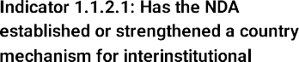
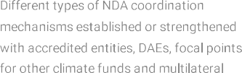
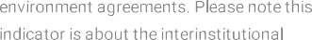

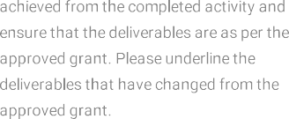
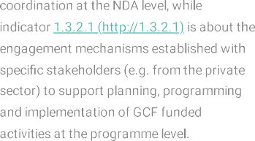

Narrative Description
During the reporting period, activities under Output 1.1.2 focused on laying the institutional and coordination foundations for effective climate governance and on preparing the ground for full operationalization of the National Climate Change Commission (NCCC) and its working structures. Initial support was provided to clarify roles, coordination needs, and implementation sequencing related to the NCCC and its Secretariat, building on the Law no. 74/2024 on Climate Action and the Government Decision No. 425/2024 on establishing and functioning of the National Climate Change Commission.
Activities under this output can be structured into two complementary blocks. The first block targets the sectoral Working Groups (WGs), which constitute the working-level bodies of the NCCC and are responsible for technical consultation, preparation, and coordination across priority sectors. During the reporting period, preparatory consultations were undertaken to define the scope, mandate, and functioning of these sectoral WGs, including the need for clear regulations governing their operation. The Inception Workshop played a key role in validating institutional priorities, identifying coordination gaps, and confirming the importance of structured sectoral engagement through thematic working groups. Support to the development of detailed regulations and operational guidance for the sectoral WGs is planned to commence in early 2026.
The second block of activities focuses on strengthening the Secretariat function of the NCCC within the Ministry of Environment, recognizing the Secretariat’s central role in ensuring continuity, institutional memory, coordination, and effective functioning of the overall climate governance mechanism. In this regard, preparatory work was undertaken for the recruitment of two national consultants—one focusing on adaptation and one on mitigation—who will support the Secretariat’s operations, including logistics, information management, coordination, and technical support to meetings and decision-making processes. Draft terms of reference for these positions were developed, consulted with the Ministry of Environment, revised based on received feedback, and are currently undergoing internal clearance procedures, with recruitment planned for early 2026.
While most tangible deliverables under this output are scheduled for subsequent implementation phases, progress achieved during the reporting period was consistent with the approved work plan and appropriately focused on consultative, preparatory, and sequencing actions required to enable effective delivery and convening of sectoral Working Groups starting in 2026.
To spur activity implementation under this output, recruitment of a Capacity Building Officer is planned. He/she will be supervising and providing support for the organization of the WGs meetings, consultations and active stakeholder engagement. Additionally, the Capacity Building Officer will be supervising the implementation of Output 2.2.5., 5.1.1. and 5.1.2.

Deliverables Achieved
ToRs for Capacity Building Officer
Draft ToR for National Climate Change Adaptation Officer to assist MoE with the NCCC Secretariat
Draft ToR for National Climate Change Mitigation Officer to assist MoE with the NCCC Secretariat

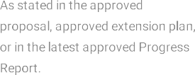
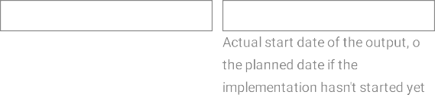
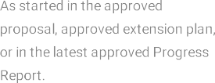
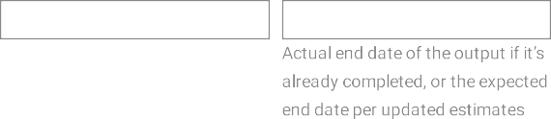

July 2027
July 2027
March 2026
May 2025

The effective project started in April 2025 and the need to align with parallel institutional and policy processes limited the scope of tangible outputs achievable during the reporting year. These factors were addressed through phased planning and prioritization of preparatory actions. The new timeline was discussed and agreed during the 1st Project Board meeting.

During the reporting period (15 April–31 December 2025), progress under Objective 2 focused on establishing the analytical, institutional, and coordination foundations necessary to strengthen Moldova’s strategic framework for effective NDC 3.0 implementation. Given the initial phase of project implementation, activities concentrated on preparatory actions, stakeholder engagement, and strategic scoping rather than the delivery of finalized policy instruments.
Key progress included validation of national and sectoral priorities through the Inception Workshop and follow-up consultations, which enabled identification of policy gaps and alignment needs across mitigation and adaptation sectors, including energy, transport, agriculture, water, forestry, and health. These consultations helped ensure that future policy support under the project is firmly grounded in national priorities, Ministry of Environment needs, and EU accession requirements.
Analytical scoping undertaken during the reporting year assessed coherence between existing national climate strategies and frameworks and the updated NDC 3.0, as well as forthcoming EU climate acquis obligations. This work provided an evidence base for sequencing future policy interventions, mitigating risks of duplication with initiatives supported by EU, NDC Partnership, and GiZ, and prioritizing areas where GCF Readiness support can add the greatest value.
Overall, progress under Objective 2 during the reporting period was consistent with the approved logframe and implementation schedule, reflecting an appropriate focus on groundwork, coordination, and adaptive planning. These efforts established the conditions necessary for accelerated delivery of policy briefs, consultations, analytical studies, and targeted policy revisions planned for subsequent reporting periods.

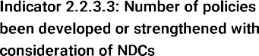
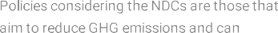
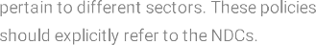
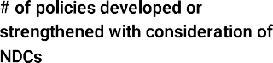

ToR Policy Officer
Inception Workshop Report

0

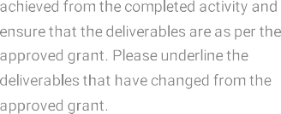

Narrative description
During the reporting period, activities under Output 2.2.3 focused on preparatory analytical work, strategic scoping, and stakeholder engagement to support future policy development for implementation of Moldova’s updated Nationally Determined Contribution (NDC 3.0). Through the Inception Workshop and subsequent consultations, sectoral priorities and policy gaps related to mitigation and adaptation were identified across key sectors, including energy, transport, agriculture, water, forestry, and health.
This output contributes to the second Readiness objective related to strengthening the national strategic framework by enhancing policy coherence, improving sectoral expertise, and reinforcing enabling environments for GCF programming in low-emission and climate-resilient investments. Initial scoping was undertaken to assess alignment needs between existing national strategies and frameworks—such as the National Programme on Adaptation to Climate Change (PNASC), the Low Emission Development Programme (LEDP), and the National Climate Change Adaptation Programme (NCCAP)—and the updated NDC 3.0, as well as forthcoming European Union climate acquis requirements. This preparatory phase informed the sequencing of planned policy support activities and helped mitigate risks of overlap with ongoing EU and GiZ supported processes.
Activities under this output are structured into two main blocks. The first block focuses on updating and strengthening the national policy framework to better integrate and mainstream NDC 3.0 elements. In this regard, preparatory work was undertaken for planning the development of a policy brief summarizing key NDC elements to be integrated into national and sectoral strategies, alongside the planning of a series of policy dialogues, roundtables, or similar consultation formats to ensure broad stakeholder participation. These activities are scheduled for launch in 2026. In addition, preparatory steps were initiated for the revision of one national policy document to incorporate NDC 3.0 priorities, supporting practical mainstreaming of climate commitments within the national strategic framework.
The second block of activities relates to analytical and research efforts to assess climate impacts in priority sectors, notably water, agriculture, and forestry. These studies are envisaged to be launched in 2026, based on research needs to be identified through the work of the sectoral Working Groups under the NCCC. Preparatory planning also foresees international learning visits and experience exchanges with selected European countries, subject to validation of priorities and modalities by the NDA.
Throughout the reporting period, close coordination was maintained with the National Designated Authority to ensure complementarity with initiatives supported by the NDC Partnership, the EU Growth Plan, and the EU integration Action Plan. Particular attention was given to aligning planned activities with Ministry of Environment priorities, including the development of systems related to monitoring, reporting, verification and accounting (MRVA), carbon pricing instruments, and implementation measures under the Growth Plan. Discussions also addressed potential support to the development of a methodological guide for installation operators on greenhouse gas emission monitoring and reporting, subject to confirmation of financing acceptability vis-à-vis EU funding sources and adjustment of implementation timelines.
With regard to support for updating the Low Emission Development Programme to 2030, preparatory analysis highlighted significant dependencies on the development of the Long-Term Low Emission Development Strategy to 2050, currently under preparation with support from GiZ. Given these external dependencies, the length of national consultation processes, and the project implementation timeframe, this activity was identified as carrying implementation risk and will be further assessed and sequenced in consultation with the National Designated Authority.
No policy instruments were finalized during the reporting year, as the focus remained on groundwork, coordination, and analytical preparation in line with the approved implementation schedule and adaptive management approach under the GCF Readiness support.
To spur activity implementation under this output, the recruitment of a Policy Officer is planned. He/she will be supervising and providing support for the policy and normative framework development. Additionally, the Officer will be supervising the implementation of Output 4.1.1 and 4.5.3.

Sectoral breakdown of each policy developed or strengthened

The policy developed covers (please highlight):

One sector
Multiple sectors

Title of the policy developed?

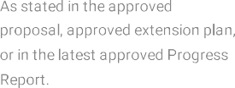
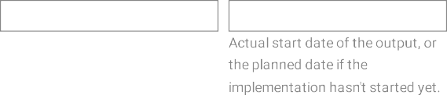
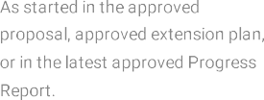
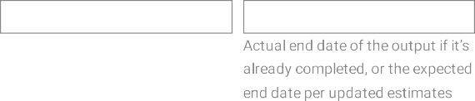

July 2027
July 2027
March 2026
July 2025

The effective project started in April 2025 and the need to align with parallel institutional and policy processes limited the scope of tangible outputs achievable during the reporting year. These factors were addressed through phased planning and prioritization of preparatory actions. The new timeline was discussed and agreed during the 1st Project Board meeting.

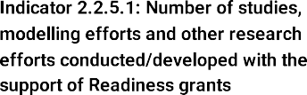
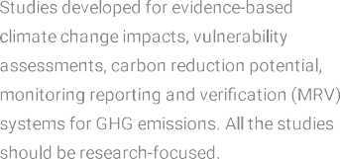
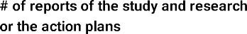

Yes/No

0

Narrative description
activities refer to research efforts (studies/) to assess the climate impacts on the water, agriculture and forestry sectors in Moldova. This activity is scheduled to be launched in April 2026, based on the research needs identified during th emeetings of the sectoral WGs of the NCCC. Additionally, 2 international learning visits/experience exchange are envisaged.
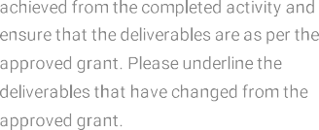

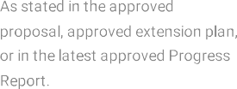
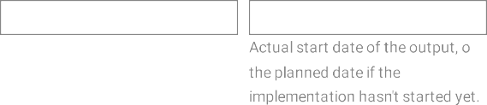
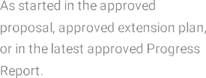
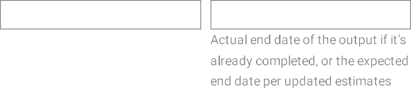

July 2027
March 2027
April 2026
September 2025

During the reporting period, the project activities focused on preparatory and enabling actions to lay the groundwork for future climate project pipeline development. Given the project’s effective start date in April 2025, which was followed by the elections period in Moldova, affecting the activities and the sequencing of those envisaged in the approved work plan the emphasis was placed on needs assessment, institutional coordination, and early engagement with key stakeholders to identify priority investment areas and capacity gaps related to concept note and full proposal development.
Discussions during the Inception Workshop and subsequent consultations confirmed strong demand from the Ministry of Environment and line institutions for structured support in developing GCF-aligned concept notes, particularly in areas linked to NDC 3.0 implementation, EU Growth Plan priorities, and sectoral adaptation and mitigation needs. These consultations informed the design and timing of pipeline-related activities planned for 2026.

0

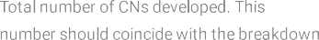


Narrative description
During the reporting period, activities under Output 4.1.1 focused on preparatory groundwork to enable future development of climate investment concept notes. Consultations with the National Designated Authority and key stakeholders helped clarify national investment priorities, potential thematic focus areas, and institutional roles.
Discussions during the Inception Workshop identified priority mitigation and adaptation sectors where climate finance support could add value, while confirming the need for strengthened institutional capacity and technical guidance for concept note development. The Project Board further confirmed the intention to develop concept notes not only for the Green Climate Fund but also for other international financing institutions, and recommended reviewing activities under this output accordingly, including possible reallocation of resources toward feasibility and preparatory studies.
No concept notes were developed or submitted during the reporting period, as activities focused on coordination and preparation in line with the approved implementation schedule. The groundwork completed in 2025 provides a basis for launching pipeline development activities in 2026.

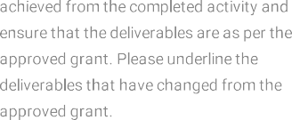

Sectoral breakdown of concept notes

One sector/multiple sectors

Project title of the Concept Note

July 2027
March 2027
June 2026
September 2025
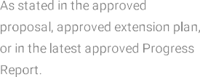
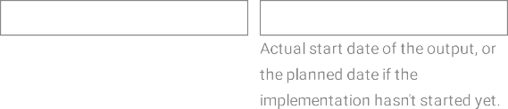
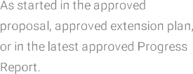
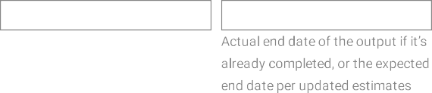
The late start of implementation in 2025 and the need to align pipeline development with evolving national and EU-supported investment frameworks limited the scope for concrete outputs during the reporting year. These factors were addressed through phased planning and early coordination.

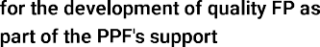
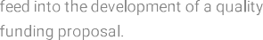
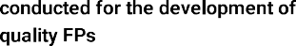

Narrative description
Activities under Output 4.5.3 were not initiated during the reporting period, in line with the approved sequencing of the Readiness support. Development of full funding proposals is planned for later stages of project implementation and is contingent upon prior progress under pipeline identification and concept note development activities.
During 2025, preparatory considerations were undertaken to clarify future requirements for full proposal development, including institutional roles, technical expertise needs, and alignment with GCF investment criteria. These considerations will inform the design of targeted support measures to be launched once concept note development activities are underway.



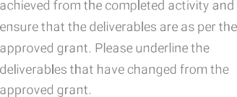

Yes/No

Yes/No

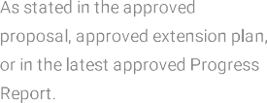
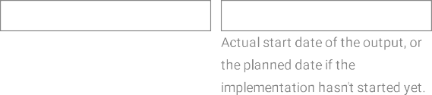
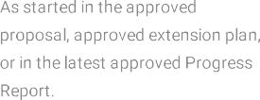
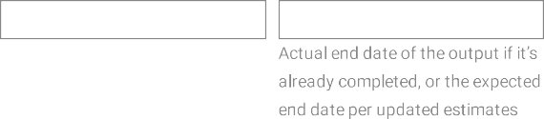

July 2026
July 2027
May 2027
June 2026

Variance/delay explanation
No variances were recorded, as implementation of this output is scheduled for subsequent reporting periods in accordance with the approved work plan.

Summary of Objective 5
During the reporting period (15 April–31 December 2025), progress under Objective 5 focused on preparatory and enabling actions to strengthen the foundations for improved climate knowledge management and transparency. Given the start-up nature of the reporting period, activities emphasized needs assessment, stakeholder consultations, and technical preparation for the modernization of national knowledge management tools, rather than delivery of fully operational systems.

Discussions held during the Inception Workshop and follow-up exchanges confirmed the importance of a functional, accessible, and regularly updated national climate information platform to support coordination, reporting, and stakeholder engagement. Particular emphasis was placed on the role of knowledge management in supporting policy coherence, NDC implementation tracking, access to climate finance, and alignment with EU transparency and reporting requirements.

Overall, progress under Objective 5 during the reporting period was consistent with the approved logframe and implementation schedule, focusing on groundwork and sequencing actions that will enable accelerated delivery of substantive knowledge management outputs in 2026.

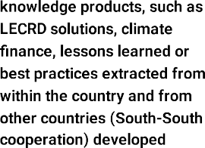
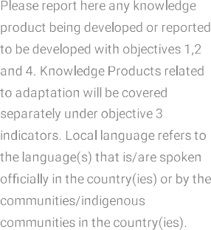

ToR for RTAMHDS Supervision

Type of entity

Total no. of knowledge products

No. of KPs produced in local language

Type of intended users

Repeat for each knowledge product

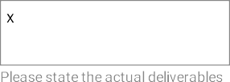

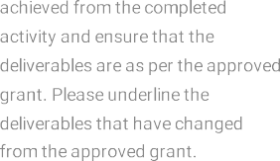

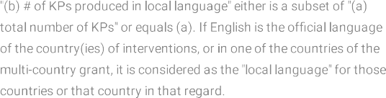

Narrative description
During the reporting period, activities under Output 5.1.1 concentrated on preparatory work to support the future modernization and strengthening of the Climate Change Information and Knowledge Management Portal (CCIKMP). The existing portal, originally developed under earlier initiatives, was identified as requiring significant updates to improve usability, content relevance, and alignment with current national climate policies and EU transparency expectations.
Initial assessments and consultations were undertaken to identify functional, technical, and content-related gaps of the existing platform, including the need for improved user navigation, clearer structuring of policy and strategic information, and more systematic updating mechanisms. These preparatory actions informed the scope and sequencing of planned technical and content upgrades to be implemented in subsequent reporting periods.
Preparatory work was undertaken for the engagement of a national IT specialist, whose role will be to support the technical design and supervision of advanced digital solutions to be integrated within the CCIKMP. As defined in the approved Terms of Reference, the IT specialist will support the development and operationalization of a Real-Time Agrometeorological and Hydrological Data System (RTAMHDS) as a core functional component of the portal, including the definition of technical requirements, data interoperability standards, security protocols, and system architecture, in close coordination with the State Hydrometeorological Service and the Ministry of Environment
No technical upgrades were finalized during the reporting year, as activities focused on analytical groundwork, definition of requirements, and preparation for procurement and implementation in line with the approved work plan.

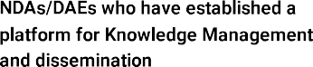
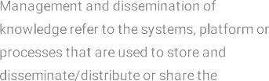
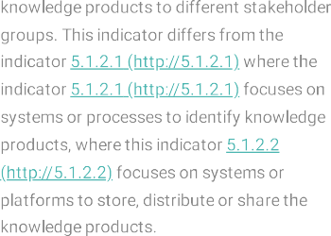

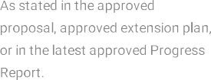
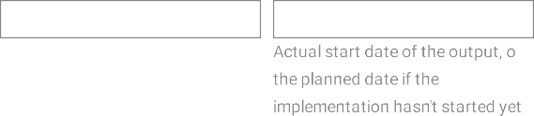
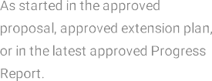
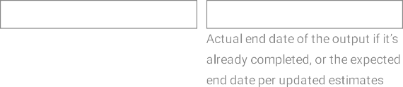

July 2027
July 2027
June 2026
March 2026

The effective project start in April 2025 and the need to align portal modernization with broader national digital and institutional frameworks limited the scope of tangible outputs during the reporting year. These factors were managed through phased planning and preparatory work.

Type of entity

No. of entities



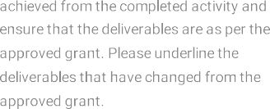

Narrative description
Activities under Output 5.1.2 during the reporting period focused on preparatory planning for the development and dissemination of climate knowledge products aimed at supporting institutional capacity building, stakeholder awareness, and informed decision-making. Through the Inception Workshop and related consultations, priority thematic areas and target audiences for future knowledge products were identified, including policy makers, sectoral institutions, and non-state stakeholders.
Preparatory considerations addressed the types of knowledge products to be developed (such as policy briefs, analytical summaries, and user-oriented explanatory materials), their alignment with national priorities and NDC 3.0 implementation needs, and their intended role in supporting policy dialogue and capacity development.
No finalized knowledge products were delivered during the reporting period, as activities remained focused on groundwork and planning in accordance with the approved implementation schedule.

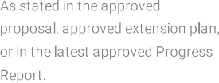
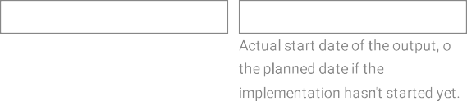
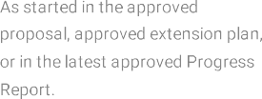
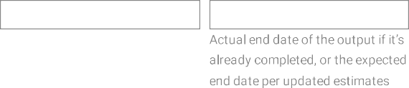

July 2027
July 2027
June 2026
March 2026

The sequencing of knowledge product development was influenced by the need to ensure consistency with forthcoming policy outputs and platform upgrades planned for subsequent reporting periods. This sequencing approach will support higher-quality and more relevant knowledge products in 2026.

